DMG MORI Open House Pfronten
Process integration, Automation, Digitalization and Sustainability: DMG MORI is shaping the future of machine tool manufacturing with holistic manufacturing solutions.

Innovative technologies for sustainable production

Start of the event year 2023: From January 30 to February 11, 2023, Germany's largest DMG MORI plant in Pfronten will once again be dominated by its traditional open house. On an exhibition area of 3,800 m², the machine tool manufacturer will celebrate with up to 5,000 visitors seven world premieres. Among the lathes, the CTX 350 will be on show. It combines the best from the previous CLX and CTX alpha series. DMG MORI will present the T1 and the T2 for entry-level universal turning. In addition, there will be the 3-axis M2 as the big sister model of the M1. In the area of the 5-axis simultaneous milling, the DMU 40 and the new monoBLOCK generation will be presented as well as and the DMF 300|11. The high standards in automation are demonstrated by 14 autonomous manufacturing solutions from a total of 28 exhibited CNC machines from all technology areas. One highlight here is the CTS (Central Tool Storage), a central tool magazine that enables automated tool supply by means of a transport shuttle.

Universal turning with state-of-the-art equipment
DMG MORI is positioning the new CTX 350 universal lathe as the successor model to both the CLX 350 and the CTX alpha 500. The world premiere consistently combines the best of both machines – the price level of the CLX series and the performance and equipment diversity of the CTX series. New features include: a main spindle with an energy-efficient synchronous motor with improved thermal behavior – it reaches a speed of 5,500 min⁻¹ – a dynamic and precise C-axis with better positioning, and a VDI-30 turret with air-oil lubrication. Optional features include a Y-axis with the largest stroke on the market of +/- 50 mm, a counter spindle with a speed of 6,000 min⁻¹ and a rear chip conveyor as an alternative to the standard one. On the control side, DMG MORI uses either SIEMENS or FANUC. Intelligent automation solutions for autonomous loading and unloading of workpieces as well as unloading of shafts by the counter spindle system complete the modular possibilities around the CTX 350.

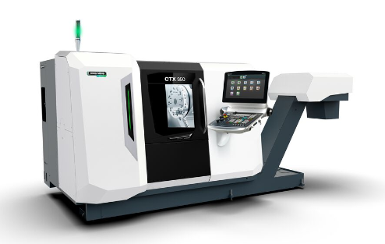
The CTX 350 combines a favorable price with high-quality equipment in universal turning.

Productive universal turning at competitive prices
Analogous to the already successful M1 vertical machining center, DMG MORI is now entering the entry-level class in universal turning with the new T1 and T2. Both models feature state-of-the-art components: a powerful main spindle, linear scales in the X-axis and a modern SIEMENS control system as well as the IoTconnector for integration into digitized manufacturing. The robust machine bed and linear guides in all axes ensure dynamic and accurate turning operations. The T1 and T2 are offered in three equipment variants COMPLETE, PLUS and PRO, so it covers different production requirements. In addition, the universal lathe is part of DMG MORI's PAYZR subscription offering. As an entry-level model in universal turning, the T1 and T2 set standards in terms of quality and reliability. The heart of the machines are the high-quality main spindles. In the T1 it reaches a speed of 4,500 rpm and a torque of 140 Nm, while the spindle in the T2 has a speed of 3,500 rpm and 319 Nm. The standard bar capacity is ø 65 mm for the T1 and ø 80 mm for the larger model. The turret offers space for twelve tools (T1: VDI 30 / T2: VDI 40). The stable machine bed is inclined at 45° to ensure optimum chip fall. Thanks to this equipment, the T1 and T2 achieve top values in its class. For example, the T1 enables a cutting depth of 4 mm in carbon steel at a cutting speed of 240 m/min.

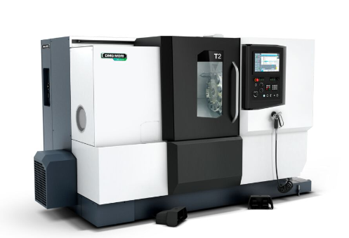

The T1 and the T2 are the new entry-level universal turning machines in the portfolio.

Cost-effective 3-axis machining of large components
Following the success of the M1 as an entry-level model in vertical machining, DMG MORI presents the new M2 as a consistent expansion in this machine segment. Like its smaller sister model, this 3-axis milling machine will also serve as a cost-effective addition to the machine park. The M2 is perfectly suited to absorb production peaks. Its clamping surface measures 1,400 x 600 mm, and travel is 1,100 x 550 x 510 mm, meaning that there is now sufficient space for larger components in this segment. The monolithic design of the machine bed gives the M2 high rigidity and optimum damping properties. Users also benefit from the high thermal load capacity of the machining center and its high-quality components. Powerful spindles with 10,000 min⁻¹ or 12,000 min⁻¹ and the fast tool magazine with 24 places are part of the equipment portfolio. All in all, the M2 allows dynamic and stable machining with very good surface quality and long tool life.
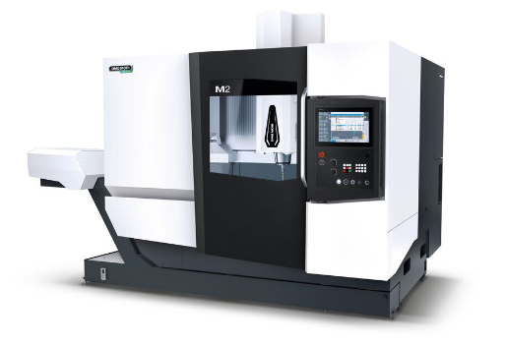

With travels of 1,100 x 550 x 510 mm, the M2 can also accommodate large components.

Versatile complete machining in a small space
More than 10,000 sold machines of the DMU 50 3rd Generation prove that compact and attractively priced universal machines for 5-axis simultaneous machining have a high priority in numerous industries. With the new DMU 40, DMG MORI is explicitly responding to this demand in the entry-level sector for versatile manufacturing solutions for complete machining. The machine is based on the concept of the DMU 50 3rd Generation and features best-in-class components from the spindles to the direct drives, as well as preparation for automated production with a PH 150 or Robo2Go. Three basic machines – DMU 40, DMU 40 PLUS and DMU 40 PRO – meet individual requirements up to the highest precision in the µm range. In short: The DMU 40 offers all the advantages of the DMU 50 3rd Generation at the most favorable entry price in the 5-axis simultaneous machining market segment.
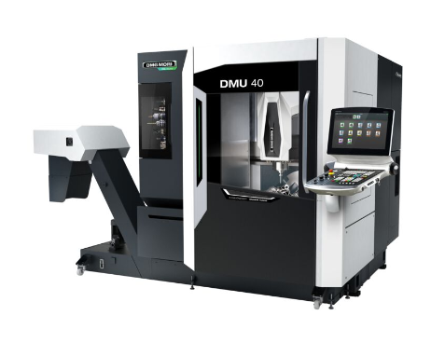
Equipment packages for individual requirements: DMG MORI has designed its new entry-level model in 5-axis simultaneous machining in three variants: DMU 40, DMU 40 PLUS and DMU 40 PRO.

Next Level of the proven monoBLOCK concept
After more than 6,000 installed machining centers of the monoBLOCK series, DMG MORI now presents the second generation of the successful machine concept. The new DMU 65 monoBLOCK 2nd Generation as well as the package machine DMU 75 monoBLOCK 2nd Generation appear in the ergonomic stealth design and impress with all-round optimized accuracy. The accuracy of the monoBLOCK 2nd Generation has been improved by 20 percent. A positioning accuracy of 4 µm is guaranteed as standard. Level 4 connectivity with IO-Link sensors and preparation for an automation interface are already on board as standard. In the further development of the monoBLOCK concept, DMG MORI has remained true to the strengths of the predecessor machines: Ergonomics, versatility and precision also characterize the new DMU 65/75 monoBLOCK 2nd Generation. The optimization of the monoBLOCK concept lies primarily in the components that are instrumental in ensuring high-precision machining. The ball screws of the X and Y axes are directly driven and feature extensive cooling measures, while the helical gear train of the rigid NC swivel rotary table ensures optimum surfaces even in continuous operation. In addition, thermosymmetrical cooling of the slide reduces inaccuracies. Temperature stability has been increased by 20 percent as a result of the improvements.
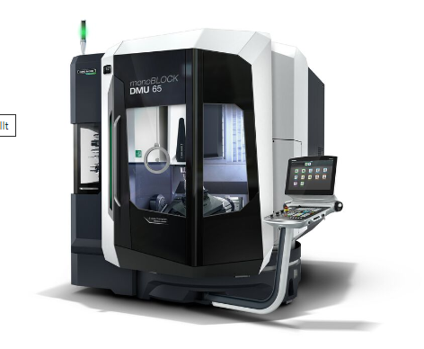
Optimized components for even more machining quality: Also in the second generation, the monoBLOCK series from DMG MORI stands for versatility, ergonomics and precision.

Innovative moving column concept for maximum machining versatility
The newly designed DMF 200|8 and DMF 300|8 have raised the moving column machine segment at DMG MORI to a new level. Based on this consistent further development, the machine tool manufacturer is now also presenting the larger DMF 300|11, where rigidity has also been increased by 20 percent compared to the previous series. Its positioning accuracy is 5 µm thanks to the stable machine bed, three linear guides in the X axis and a holistic cooling concept. With traverse paths of 3,000 x 1,100 x 1,050 mm, DMG MORI was able to increase the work envelope by 40 percent, and the process-safe tool change behind the work table was also adopted from the smaller sister models. In the standard version, the tool magazine offers space for 40 tools with lengths of up to 400 mm. Constant projections also ensure consistent milling performance. In its ergonomic stealth design, the DMF 300|11 is also comfortable to operate and prepared for productive automation solutions.
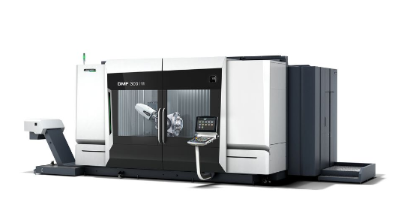
The DMF 300|11 enables high-precision machining over traverse paths of 3,000 x 1,100 x 1,050 mm.

Competitive through innovative automation solutions
Flexible automation of production processes is high on the agenda of an increasing number of companies. The quest for productivity and efficiency in order to remain competitive on the global market is driving this development. After all, the better the utilization of a production facility, the better its economic as well as ecological balance. DMG MORI has been shaping this development towards increasingly autonomous processes for many years with innovative automation solutions. The portfolio now comprises 57 automation solutions in 13 product lines for workpiece or pallet handling - including the complete hardware and software. In addition, there are the PH-AGV and WH-AMR automated guided vehicles. DMG MORI can thus equip and in many cases retrofit 150 different machine models. 14 exemplary automation solutions can be seen at the in-house exhibition in Pfronten. Pallet handling systems such as the PH 150, the PH Cell series and the round pallet storage systems RPS 3 and RPS 9, the workpiece handling system WH 3 Cell as well as the robot automation systems MATRIS light and the Robo2Go family represent the broad spectrum.

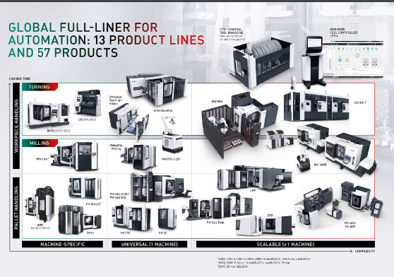
DMG MORI's portfolio comprises 57 automation solutions in 13 product lines for machine-specific, universal and scalable solutions, including the complete hardware and software: from machines with tool and pallet change, flexible manufacturing cells – to automatic tool supply (CTS), driverless transport vehicles (AGV & AMR) and the various turnkey expansion stages of flexible manufacturing systems, such as LPP or MATRIS, rounded off by the DMG MORI CELL CONTROLLER LPS 4.

Flexible tool magazine for up to 1,440 tools
The wheel magazine developed by DMG MORI, which has been sold over 1,600 times, offers fast provisioning times, a compact design and operates absolutely reliably. Based on this technology, the machine tool manufacturer has developed the CTS (Central Tool Storage), a central tool magazine. Thanks to a footprint of just 29 m², it can be installed in a space-saving manner at any location in production. There, with space for up to 1,440 (ISO 40) or 960 (ISO 50) tools, it functions as the basis for an automated tool supply system, which DMG MORI will demonstrate in Pfronten by means of a transport shuttle. The modular tool magazine has a compact design and can also be expanded in stages by 360 (ISO
40) or 240 (ISO 50) tools. At full capacity, the CTS measures 6,500 x 4,450 mm.
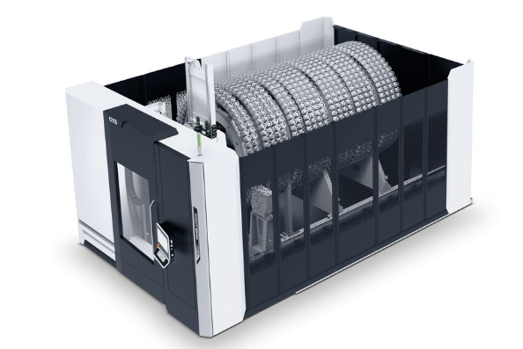

CTS – Central Tool Storage: flexible tool magazine for up to
1.440 tools.

Efficient high-speed cutting at 30,000 min⁻¹
DMG MORI Components, such as the extensive spindle portfolio of the machine tool manufacturer, contribute significantly to quality and reliability in machining. Many years of experience and technical know-how flow into the products developed and manufactured by DMG MORI – as in the case of the speedMASTER 30k. The new high-speed spindle achieves a speed of up to 30,000 rpm. speedMASTER spindles are designed for high-speed milling applications and are used in horizontal and vertical machining centers such as the NHX 4000/5000 3rd Generation and NVX 5000 2nd Generation as well as the monoBLOCK series. The previously available spindle range already came up to speeds of up to 15,000 min⁻¹ or 20,000 min⁻¹. With the new speedMASTER 30k, DMG MORI enables even faster milling and shorter machining times.

